**SUPPLEMENTARY DATA 1**

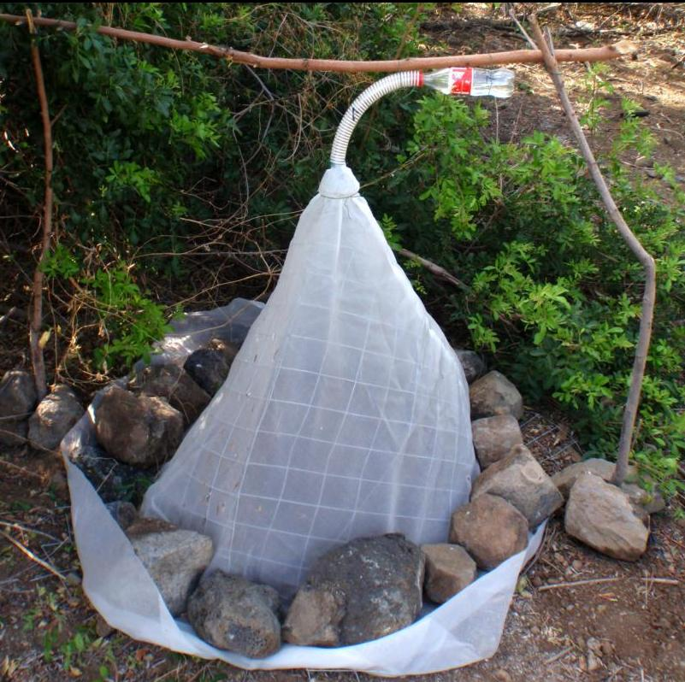

Schema à faire

**SUPPLEMENTARY DATA 2**

D:\Mes Données\Recherche\Diapause_Biologie\Article\Figures\PA010109.tif

Photo ou schéma à faire

**SUPPLEMENTARY DATA 3**

**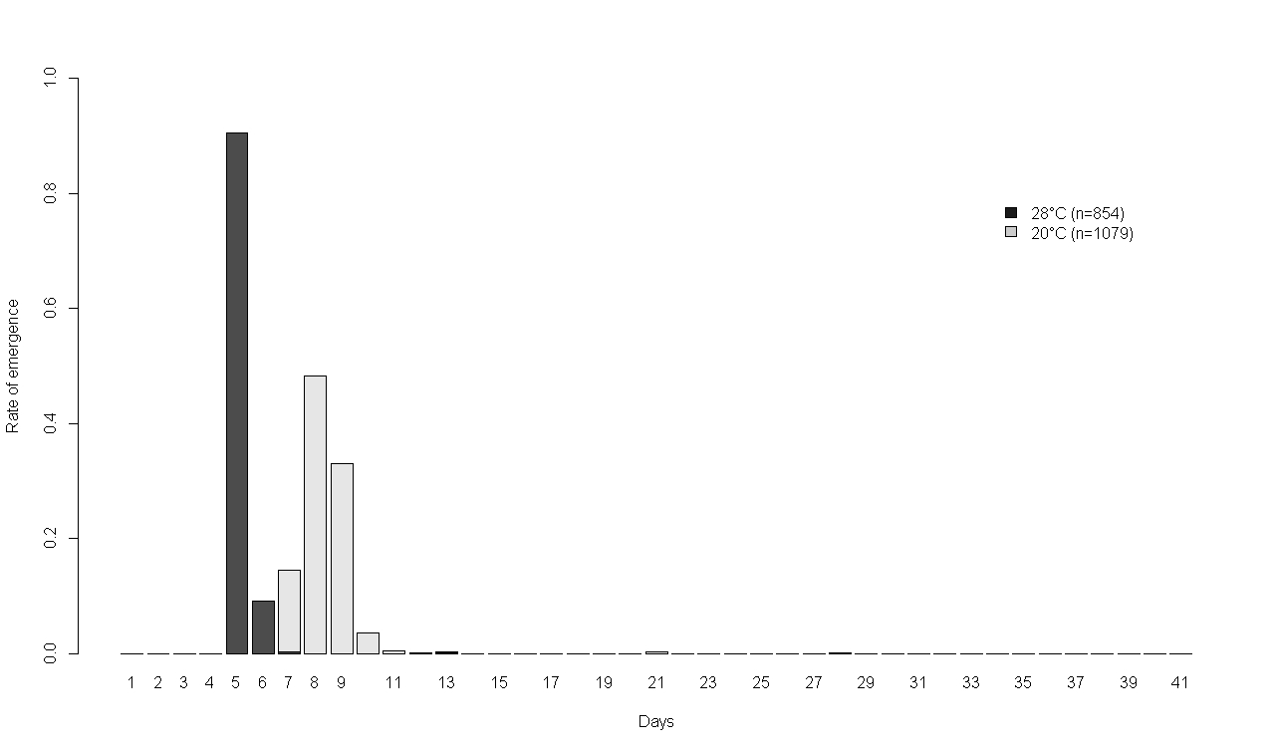**

Adult emergence at two different temperatures (20°C and 28°C) during the first 41 days

**SUPPLEMENTARY DATA 4**

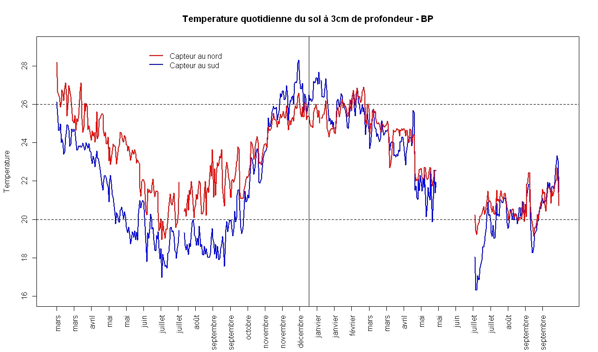

*Soil temperature under three centimeters on the border of a mango tree at the north and south direction at Saint-Pierre, Reunion Island.*

**SUPPLEMENTARY DATA 5**

**D:\Mes Données\Recherche\Diapause_Biologie\Article\Figures\Temperatures_contantes_hiver11.tiff**

Adult emergence for larvae collected in winter 2011 at two constant temperatures (20° and 26°C)

**SUPPLEMENTARY DATA 6**

**D:\Mes Données\Recherche\Diapause_Biologie\Article\Figures\SupplementaryX.tiff**